Лабораторная работа №1
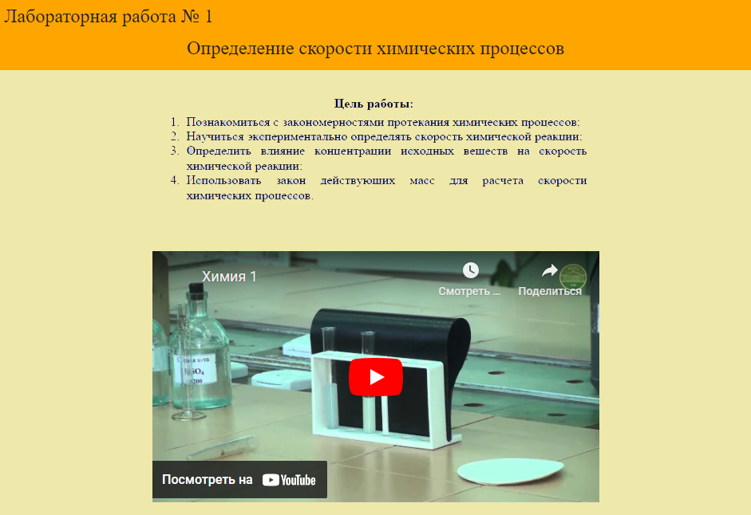
https://www.youtube.com/watch?v=EdMpZlJrPBg&ab_channel=%D0%A6%D0%94%D0%9E%D0%92%D0%93%D0%9B%D0%A2%D0%A3%D0%B8%D0%BC.%D0%93.%D0%A4.%D0%9C%D0%BE%D1%80%D0%BE%D0%B7%D0%BE%D0%B2%D0%B0
